practical test 1

Due Date: Saturday, 25 August 2023, 5:30 PM

Weight: 15% (50 Points)

# **instructions**

Please ensure that you submit your SQL file (**PT1YOURNAME.sql**) to the Canvas (**Assignments 🡪 Assessment Task 2A 🡪 Practical Test 1: SQL**) by the due date.

**Tests submitted after the due date will be accepted as follows:**

* Tests submitted between 0-24 hours after the due date: 20% penalty.
* Tests submitted between 24-48 hours after the due date: 50% penalty.
* Tests submitted more than 48 hours after the due date will not be accepted.

--

**Extensions**

If you will not be able to meet the due date for an assessment you may apply to your teacher for an extension of up to seven days by completing the Application of Time to Submit Assessment Work Form at

https://www.rmit.edu.au/content/dam/rmit/documents/Students/Student_forms/Application-for-extension-of-time-to-submit-work.pdf

Applications for an extension of time must be received at least 24 hours before the due date for an assessment.

--

**Special Consideration**

If unforeseen circumstances beyond your control prevent you from submitting your work on time you may be eligible to apply for special consideration. For further information regarding special consideration, please refer to the RMIT Special Consideration page at

https://www.rmit.edu.au/students/student-essentials/assessment-and-results/special-consideration

--

**Academic Integrity**

In addition to meeting assessment timelines academic integrity is about honest presentation of academic work. Students must be accountable for the originality and validity of assessment submission, and not assist others in any form of plagiarism or cheating.

https://www.rmit.edu.au/students/student-essentials/assessment-and-results/academic-integrity

# SCENARIO – database for the associate degree in it program

The Associate Degree in IT is a practical two-year program that gives students the basic skills required to perform a range of in-demand specialist IT functions such as technical support, software development, database administration, and network administration. It provides a guaranteed pathway into a relevant bachelor’s degree.

Students belong to groups and are enrolled to courses.The courses are taught by teachers*.*

# **Assumptions**

* A student belongs to one group only. Each group can have many students.
* A student is enrolled to many courses. Each course has many students enrolled in it.
* A teacher can teach many courses. Each course is taught by many teachers.
* Each group has a mentor (teacher in charge).
* Each course has a course co-ordinator (teacher in charge).
* To complete a course a student must score at least 50 (numerical grade >= 50).
* Final Grades: 0-49 NN, 50-59 PA, 60-69 CR, 70-79 DI, 80-100 HD
* To graduate (complete the AD006 program) a student must complete the following eight courses.

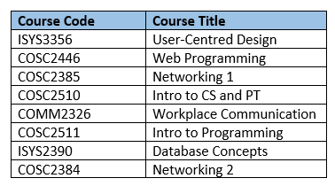

**Course Coding:**

COSC – Computer Science Course

ISYS – Information Systems Course

COMM – Communication Course

# **AD006 DATABASE - SCHEMA:**



# **download ad006 database**

Download “**AD006 Database**” files from Canvas.

**Assignments 🡪 Practical Test 1: SQL 🡪 AD006 Database.**

Run two files: **ad006_create_tables.sql** and **ad006_insert_data.sql.**

# **AD006 DATABASE - TABLES**

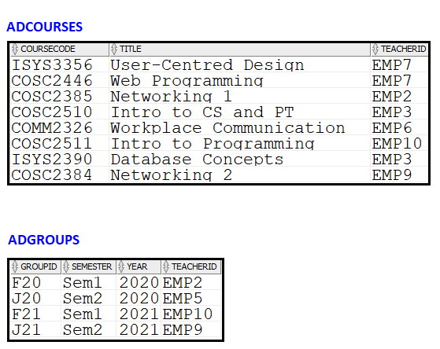

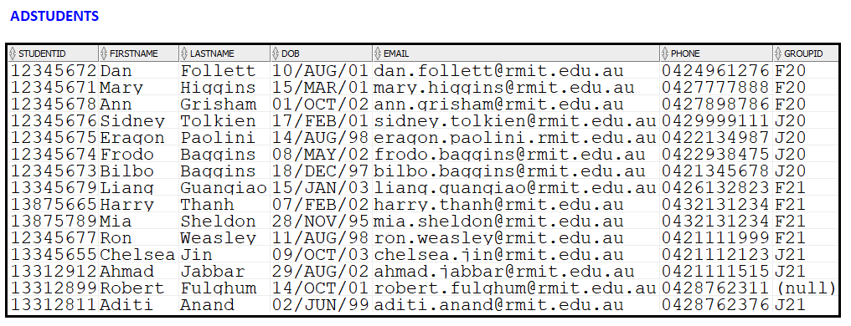

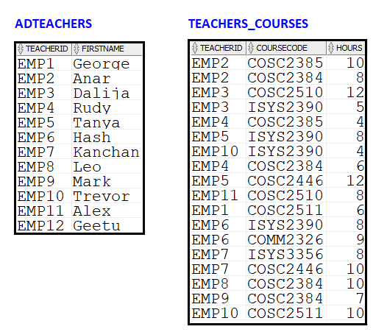

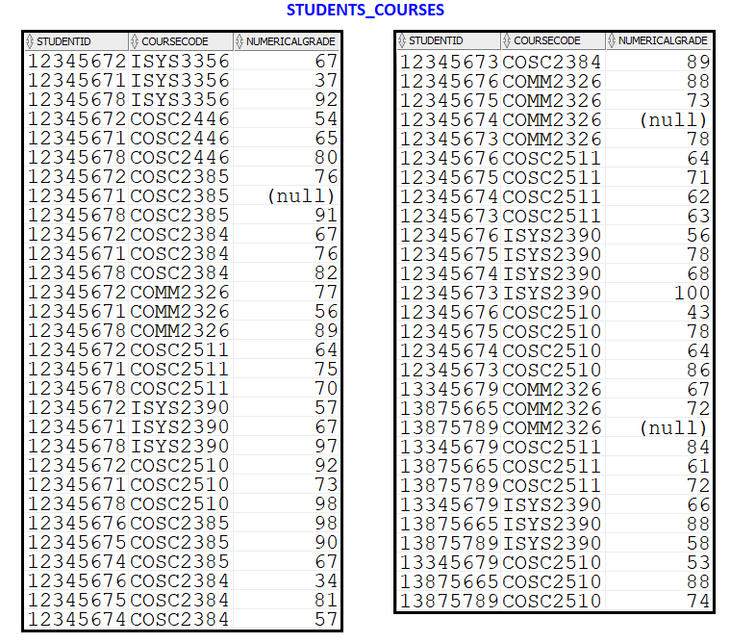

# **with a reference to “add006 database” create SQL queries to answer the following questions. (50 points)**

# **name the sql file which will contain your sql queries pt1yourname.sql**

The file should contain your name, student number, and all queries.

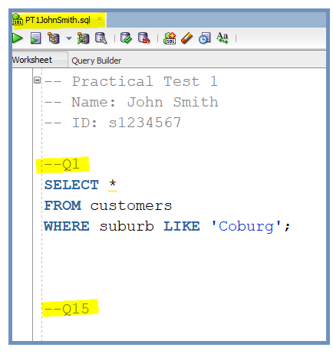

**NOTE:**

* **For each correctly written SQL query that returns correct output you will get full points.**
* **Points will be deducted for each incorrect query. Points deduction will depend on the type of error.**

# **Q1-Q7 (7 x 3 = 21 points)**

**Q1** Which group Frodo Baggins belongs to? Display the group ID.

**Q2** Display the ID of all teachers teaching ISYS2390 course.

**Q3** A valid email address must contain an ‘@’ character. Display all information about students who do not have a valid email address.

**Q4** Display the first name, email address, and phone number of all students who belong to any group.

**Q5** What is an average numerical grade for the student whose ID number is 12345672?

**Q6** Display the student ID and course code for all missing results.

**Q7** Display the course code and title for all computer science courses.

# **Q8-Q13 (6 x 4 = 24 points)**

**Q8** For each course, display the course code, lowest grade, highest grade, and average grade. Round average to two decimal places. Use aliases for calculated columns.

**Q9** How many students completed COSC2385 course? To complete a course a student must score at least 50 (numerical grade >= 50).

**Q10** Display the ID and average grade of all students who have an average grade greater or equal 80. Round the average grade to the closest integer. Use alias for the average grade column.

**Q11** For each teacher, display the ID and the number of hours they are teaching. Sort results in a descending order based on the number of hours. If two teachers are teaching the same number of hours, sort them in an ascending order based on teacher ID.

**Q12** How many students are enrolled to each group? Display the group ID and the number of students enrolled. Display only groups that have more than 3 students enrolled.

**Q13** A student enrolled to the AD006 program pays a 1000 dollars course fee for every course they are enrolled to. How much a student with an ID 12345673 already paid for courses? Display the amount paid. Use alias (Fees Paid - Student 12345673) for a calculated column.

# **Q14 OR Q15 (5 points)**

Note: Complete only one of the following 2 questions (Q14 or Q15).

**Q14** This semester you are enrolled to four courses: COSC2511, COSC2446, COSC2384, and ISYS2390. How many different teachers are teaching these courses, and how many hours (total) teachers deliver these courses?

Your output should look like the following:

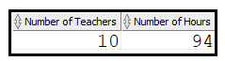

**Q15** For each information systems or communication course display the total number of moderate grades - include PA (50-59) and CR (60-69) grades. Sort results in an ascending order based on the total number of courses. Do not display the result if the number of moderate grades is 1.

Your output should look like the following:

